EXP 14: CREATE AVIRTUAL HARD DISK AND ALLOCATE THE STORAGEUSING VM WARE WORKSTATION.
DATE:
AIM: To create a virtual hard disk and allocate the storage using vm ware workstation
PROCEDURE:
STEP 1:GOTO VM WARE WORKSTATION.
STEP2: RIGHT CLICK THE VM AND GOTO THE SETTINGS.
STEP 3: ADD HARDWARE WIZARD AND SELECT SCSI AND CLICK NEXT.
STEP 4: CREATE NEW VIRTUAL DISK.
STEP 5: SELCT THE DISK SIZE AS 2.0. AND SELCT SPLIT VIRTUAL DISK INTOMULTIFILES.
STEP 6: GIVE NAME AND CLICK THE FINISH.
DESIGN:
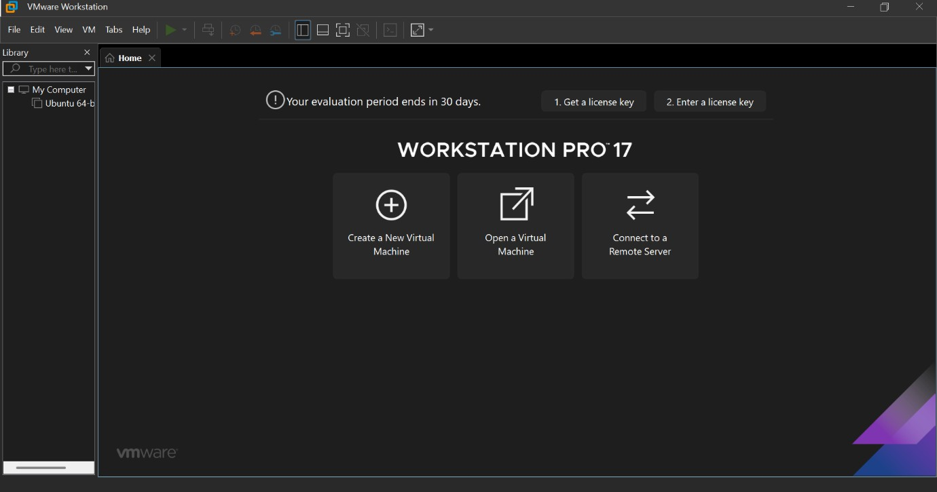
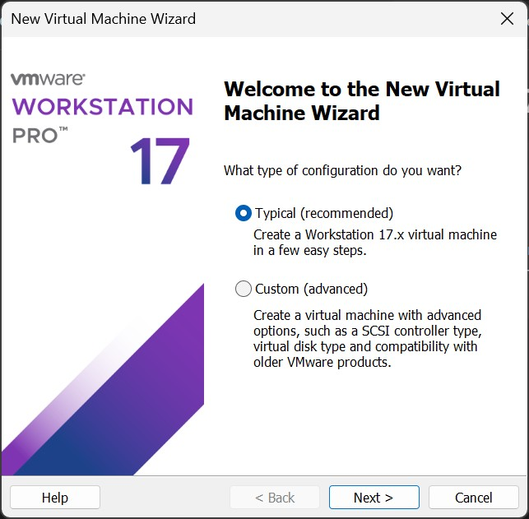

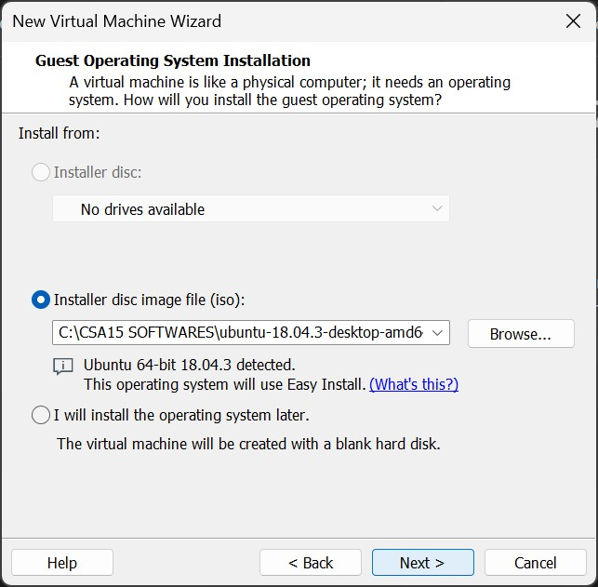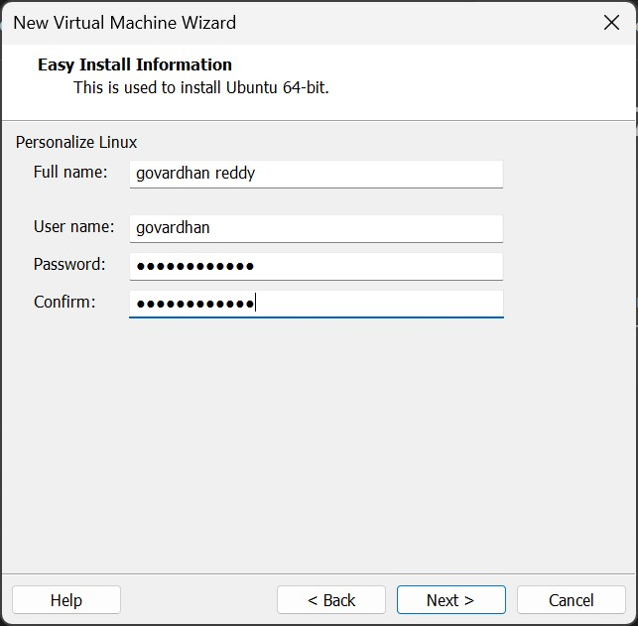

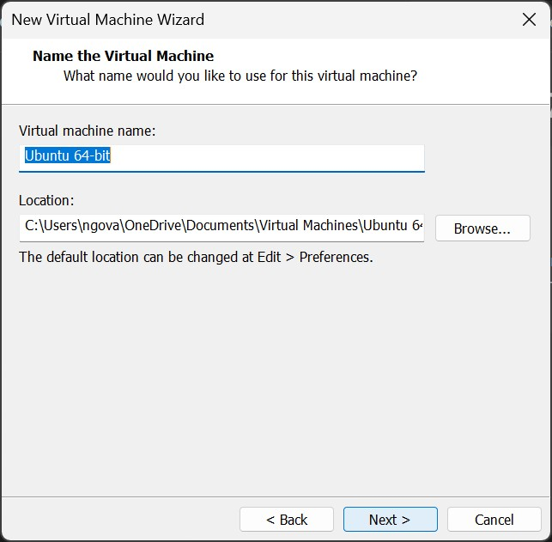

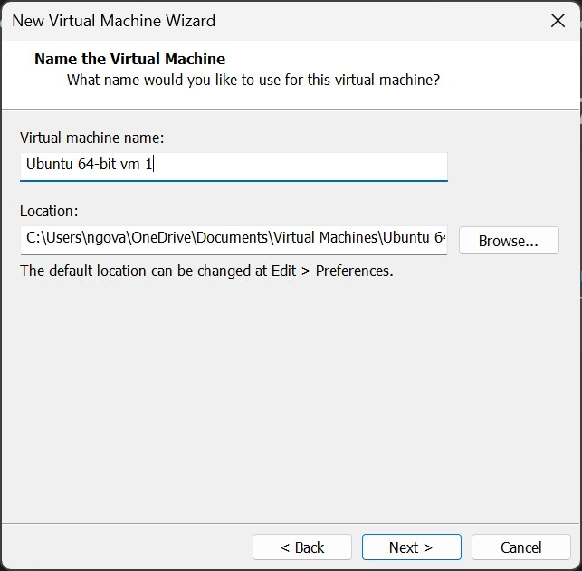

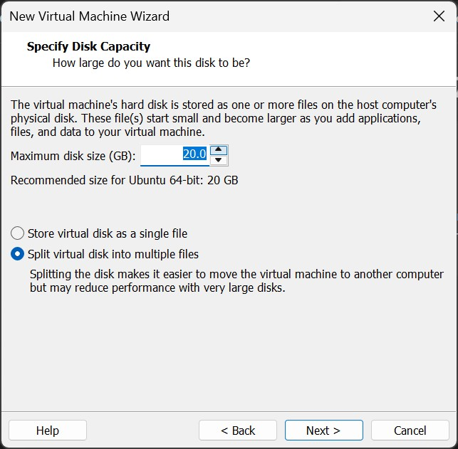

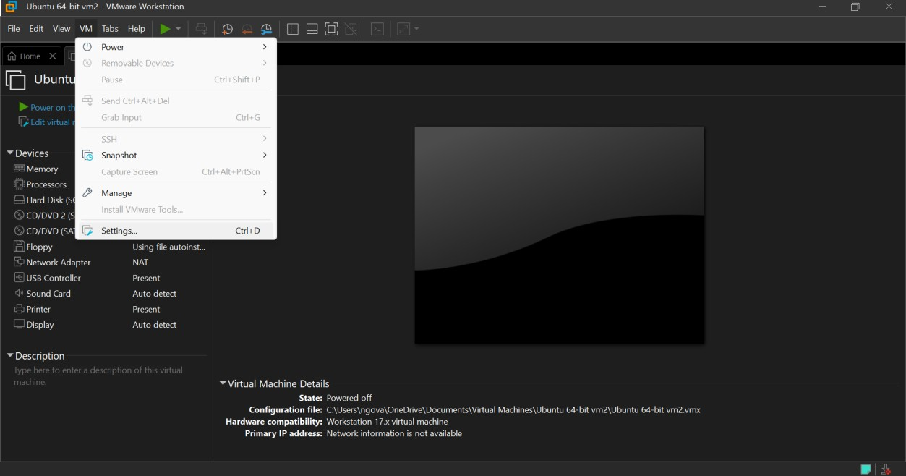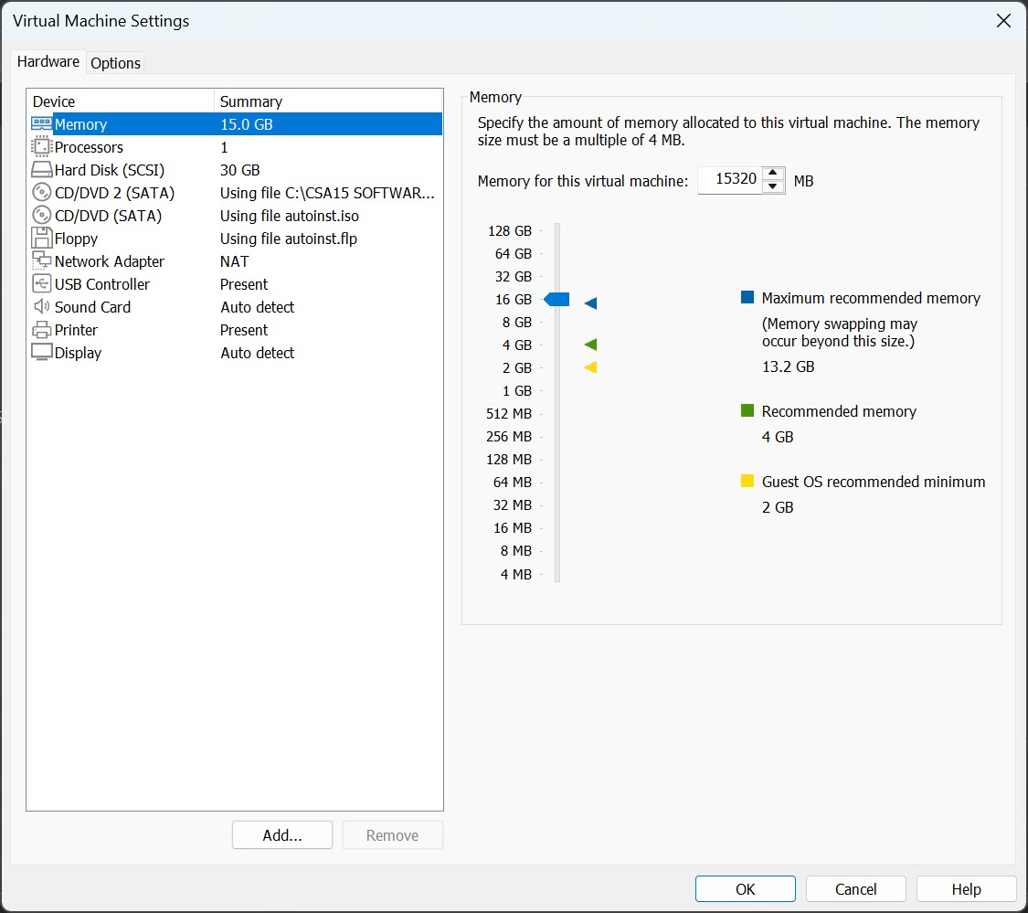
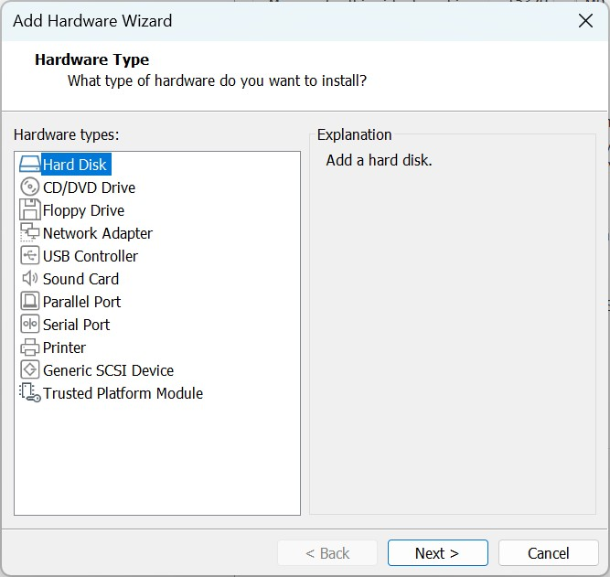

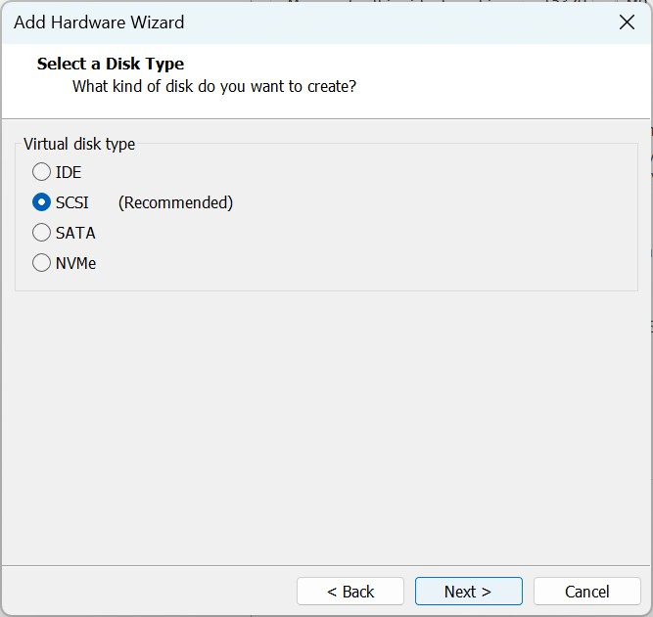

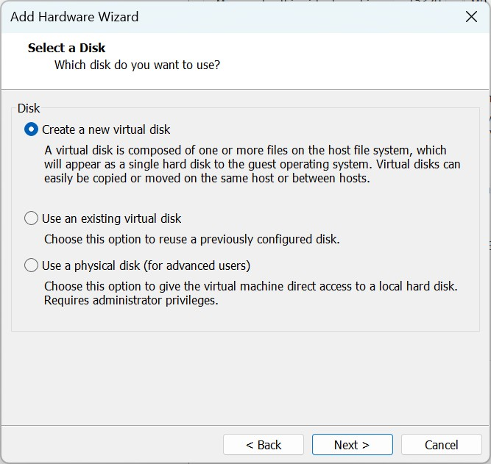
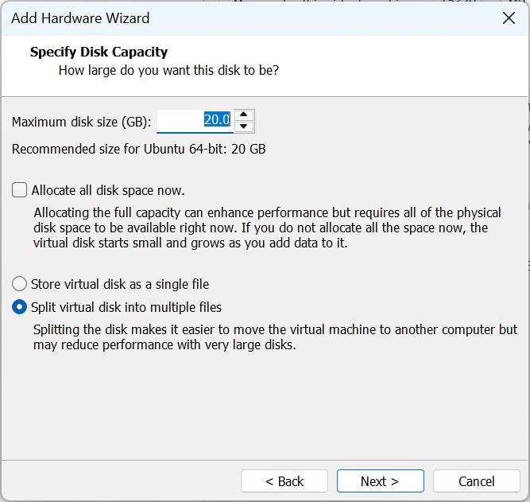
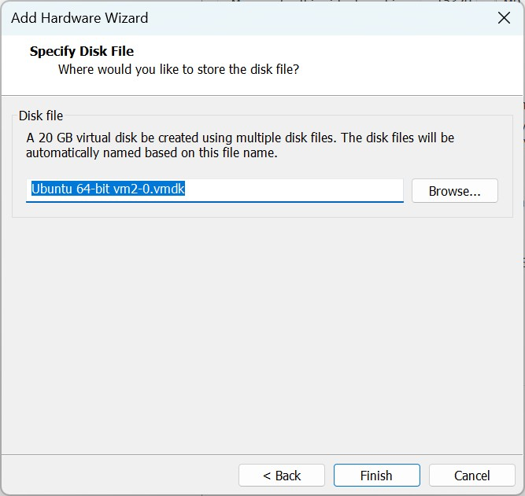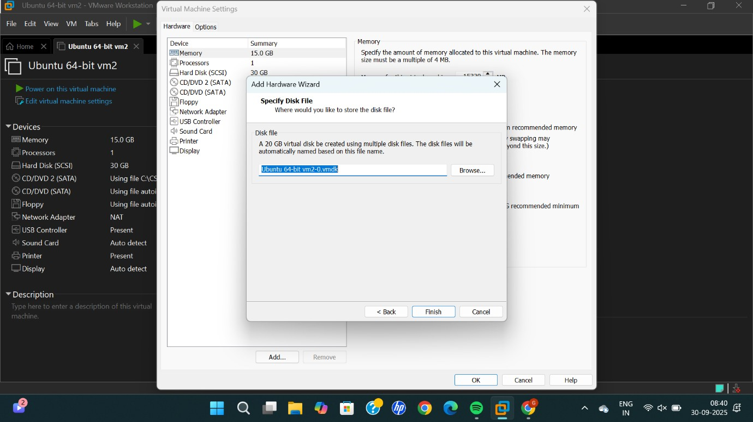

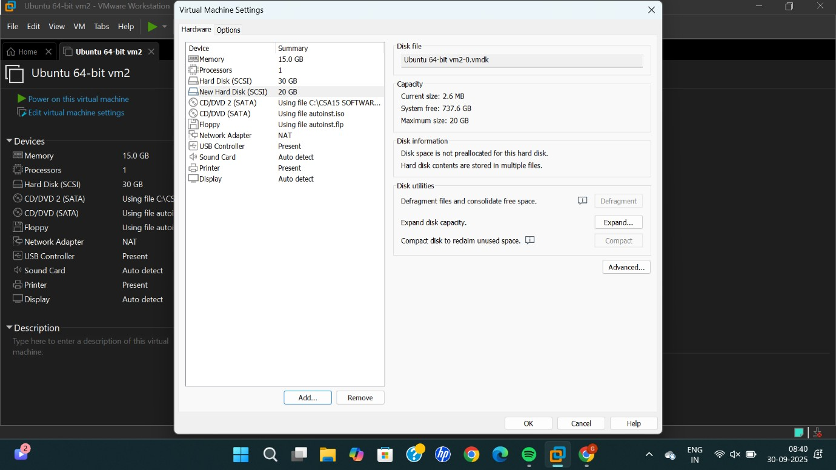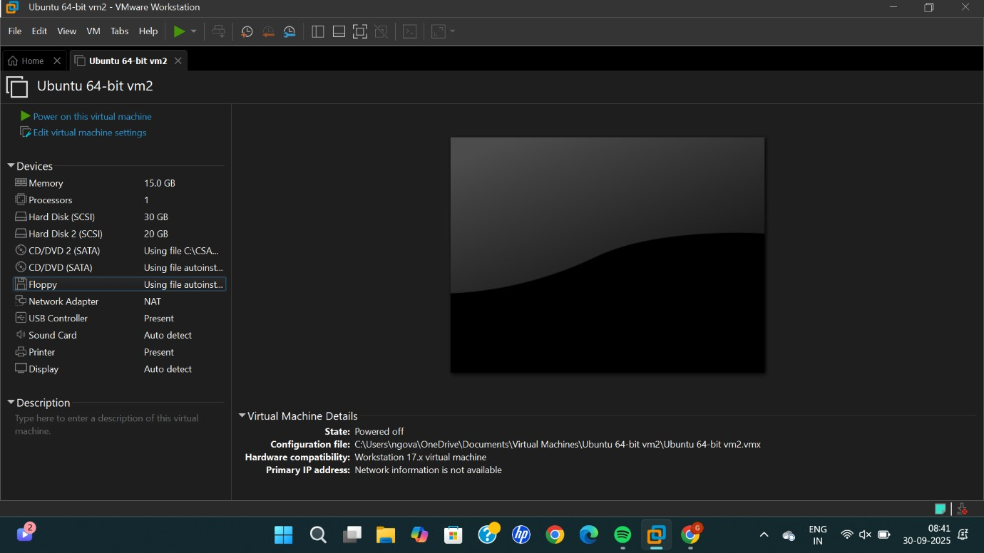

RESULT:
Successfully created a virtual hard disk and allocate the storage using vm ware workstation.

